**Getting started with AGGA**

1. By default the app is loaded with the russian interface, so as to change the language, please, push the button. To create the structure of a system, push the button «System structure specification»  , you will see the window as it is in Fig. 1.

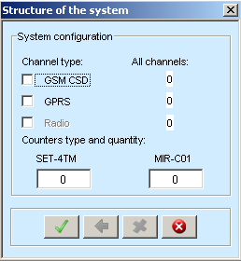

Fig. 1. The window for the specification of system architecture

2. Choose the channel type (GSM CSD or GPRS) and set the number of electricity counters of each type (SET-4TM or MIR-C01) in the communication channel (Fig. 2, a). To finish the creation, click the button .

|  |  |
| --- | --- |
| a | b |

Fig. 2.

After generating a new channel, we can see that the filed “All channels” has been changed for GPRS type and other buttons are enabled,  - undo last creation and  - reset the configuration. Let us create one more GPRS channel with two SETs and three MIRs, and one GSM CSD channel with one SET and two MIRs.

3. Also, in order to start the simulation, it is necessary to specify some simulation settings in the window presented in Fig. 3, a. It can be opened by clicking the button . In Simulation settings, modeling time in days can be set, and it is obligatory to choose groups of parameters that will be requested, after pushing the button “Save”. If not one of the presented groups has been selected, then the application will produce an error.

|  |  |
| --- | --- |
| a | b |

Fig. 3. Simulation settings

4. After the system configuration generating, the user can change some settings of the communication channels using the windows in Fig. 4 (press button  or ) and the electricity counters (press button ) using the window in Fig. 3, b.

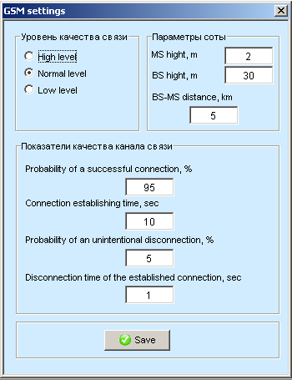 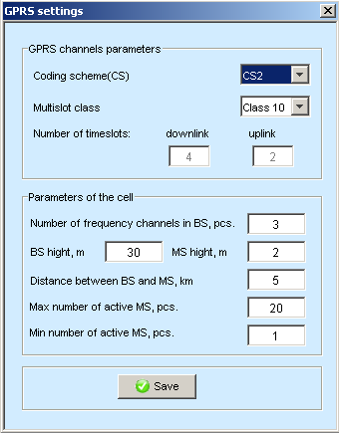

Fig. 4. Communication channels settings

5. After all input parameters are specified, the user can start the simulation process by clicking  which will take some time depending on the complexity of the generated system and the simulation time. The user can observe the progress animation on the screen. When the simulation is finished, the calculated statistics will be displayed in the main window, and some outputs and their graphical visualization are available by clicking the buttons .

Also, you can see a small video **Getting started with AGGA.avi** with the same steps described in the instructions.